**EXPERIMENT -17**

**AIM**:

To change the hardware compatibility of a Virtual Machine (VM), either by cloning or creating a new one, which is already created and configured using Oracle VirtualBox.

**PROCEDURE:**

**STEP 1;** Open Oracle VirtualBox and ensure the VM is powered off.

**STEP 2;** Select the virtual machine and click 'Settings'.

**STEP 3;** Under System > Motherboard, adjust Base Memory (RAM) as needed.

**STEP 4;** Under System > Processor, increase or decrease the number of CPUs.

**STEP 5;** Under Display > Screen, change the Video Memory size.

**STEP 6;** Under Storage, add or modify the virtual disk as per the new requirement.

**STEP 7;** Click OK to apply the changes and start the VM to verify the configuration.

**IMPLEMENTATION;**

**OUTPUT;**

**STEP 1;** Open Oracle VirtualBox and ensure the VM is powered off.

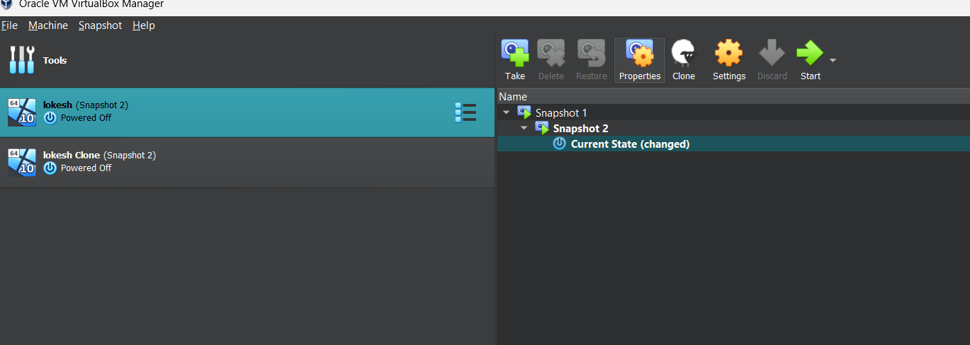

**STEP 2;** Select the virtual machine and click 'Settings'.

**STEP 3;** Under System > Motherboard, adjust Base Memory (RAM) as needed.

**STEP 4;** Under System > Processor, increase or decrease the number of CPUs.

**STEP 5;** Under Display > Screen, change the Video Memory size.

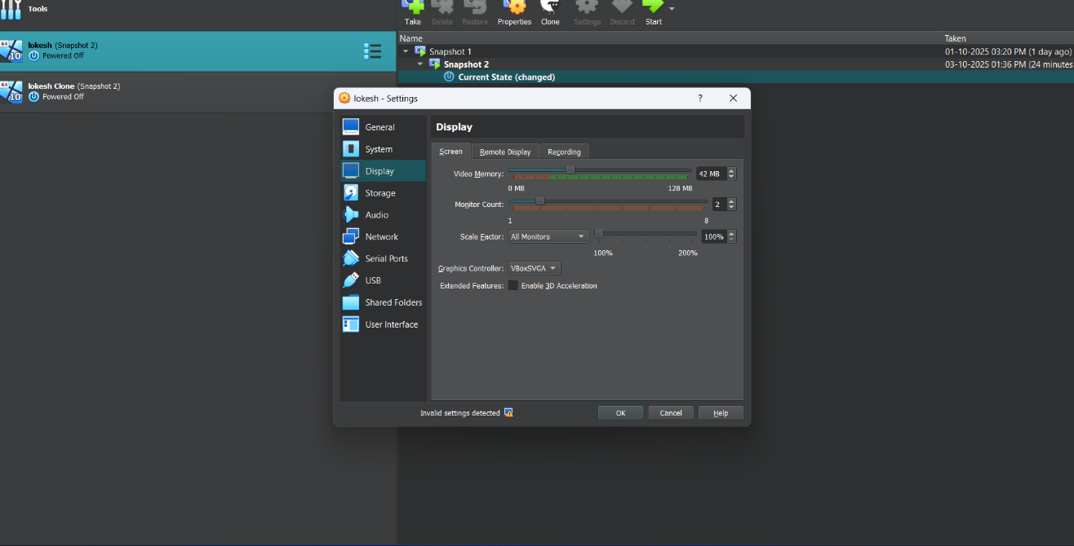

**STEP 6;** Click OK to apply the changes and start the VM to verify the configuration.

**RESULT:** The hardware compatibility of the existing or cloned virtual machine was successfully changed using Oracle VirtualBox. The updated VM functioned properly with the new hardware settings.